Zimbabwe

## GNI per capita and development level

The data set shows the GNI per capita and development level of the country each year.

## # A tibble: 19 x 5  
## country iso3c date GNIperCapita devCategory   
## <chr> <chr> <dbl> <dbl> <chr>   
## 1 Zimbabwe ZWE 1996 891. Low Income   
## 2 Zimbabwe ZWE 1998 1148. Lower Middle Income  
## 3 Zimbabwe ZWE 2000 1127. Lower Middle Income  
## 4 Zimbabwe ZWE 2002 546. Low Income   
## 5 Zimbabwe ZWE 2003 569. Low Income   
## 6 Zimbabwe ZWE 2004 996. Low Income   
## 7 Zimbabwe ZWE 2005 987. Low Income   
## 8 Zimbabwe ZWE 2006 995. Low Income   
## 9 Zimbabwe ZWE 2007 1023. Low Income   
## 10 Zimbabwe ZWE 2008 1048. Lower Middle Income  
## 11 Zimbabwe ZWE 2009 692. Low Income   
## 12 Zimbabwe ZWE 2010 836. Low Income   
## 13 Zimbabwe ZWE 2011 921. Low Income   
## 14 Zimbabwe ZWE 2012 1068. Lower Middle Income  
## 15 Zimbabwe ZWE 2013 1108. Lower Middle Income  
## 16 Zimbabwe ZWE 2014 1118. Lower Middle Income  
## 17 Zimbabwe ZWE 2015 1102. Lower Middle Income  
## 18 Zimbabwe ZWE 2016 1112. Lower Middle Income  
## 19 Zimbabwe ZWE 2017 1144. Lower Middle Income

## GDP growth and economic growth classification

The data set shows the GDP growth and the ecomic growth classification of the country each year.

## # A tibble: 19 x 5  
## country iso3c date GDPannualGrowthRate GDPgrowthCategory4  
## <chr> <chr> <dbl> <dbl> <fct>   
## 1 Zimbabwe ZWE 1996 10.4 fast growth   
## 2 Zimbabwe ZWE 1998 2.89 moderate growth   
## 3 Zimbabwe ZWE 2000 -3.06 negative grwoth   
## 4 Zimbabwe ZWE 2002 -8.89 negative grwoth   
## 5 Zimbabwe ZWE 2003 -17.0 negative grwoth   
## 6 Zimbabwe ZWE 2004 -5.81 negative grwoth   
## 7 Zimbabwe ZWE 2005 -5.71 negative grwoth   
## 8 Zimbabwe ZWE 2006 -3.46 negative grwoth   
## 9 Zimbabwe ZWE 2007 -3.65 negative grwoth   
## 10 Zimbabwe ZWE 2008 -17.7 negative grwoth   
## 11 Zimbabwe ZWE 2009 12.0 fast growth   
## 12 Zimbabwe ZWE 2010 19.7 fast growth   
## 13 Zimbabwe ZWE 2011 14.2 fast growth   
## 14 Zimbabwe ZWE 2012 16.7 fast growth   
## 15 Zimbabwe ZWE 2013 1.99 slow growth   
## 16 Zimbabwe ZWE 2014 2.38 slow growth   
## 17 Zimbabwe ZWE 2015 1.78 slow growth   
## 18 Zimbabwe ZWE 2016 0.756 slow growth   
## 19 Zimbabwe ZWE 2017 4.70 moderate growth

## Development trend

The plot shows the development trend of the country.

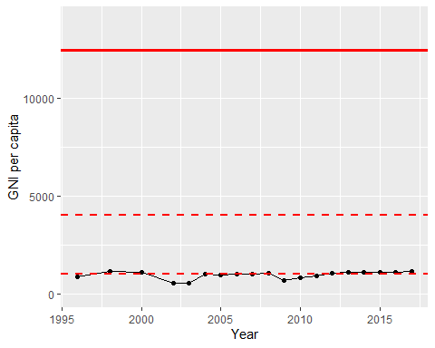

GNI Per Capita Trend